A Mini Project Report

On

**“Railway Management System”**

by

Aayaan Shaikh (56)

Saher Shaikh (57)

*Under the guidance of*

Prof. R.B. Lagdive



Department of Computer Engineering

Trinity Academy of Engineering, Pune

**SAVITRIBAI PHULE PUNE UNIVERSITY**

**2024-25**

** Department of Computer Engineering**

**Trinity Academy of Engineering, Pune**

**Date: 19/09/2024**

**CERTIFICATE**

This is to certify that,

Aayaan Shaikh (56)

Saher Shaikh (57)

of class **T.E Computer**; have successfully completed their mini project work on **“Railway Management System’’** at **Trinity Academy of Engineering, Pune** in the partial fulfillment of the Graduate Degree course in **T.E** at the department of **Computer Engineering** in the academic Year 2024-2025 Semester – I as prescribed by the SavatribaiPhule PuneUniversity

**Prof. R.B.Lagdive Ms. S. N. Maitri Dr. R. J. Patil**

**Project Guide Head of Department Principal**

**Acknowledgements**

With deep sense of gratitude we would like to thanks all the people who have lit our path with their kind guidance. We are very grateful to these intellectuals who did their best to help during our project work.

It is our proud privilege to express deep sense of gratitude to **Dr. R. J. Patil,** Principal of KJEI’s TAE, Pune for his comments and kind permission to complete this project. We remain indebted to Ms. S. N. Maitri, H.O.D. of Computer Engineering Department for his timely suggestion and valuable guidance.

The special gratitude goes to Prof. R.B.Lagdive excellent and precious guidance in completion of this work .We thanks to all the colleagues for their appreciable help for our working project. With various industry owners or lab technicians to help, it has been our endeavor to throughout our work to cover the entire project work.

We also thankful to our parents who providing their wishful support for our project completion successfully .And lastly we thanks to our all friends and the people who are directly or indirectly related to our project work.

Aayaan Shaikh (56) Saher Shaikh (57)

i

|  |  |  |
| --- | --- | --- |
|  | **Contents** |  |
| **Sr. No.** | **Topic** | **Page No.** |
|  | **Acknowledgement** | i |
|  | **Contents**  **Abstract** | ii |
| **Chapter-1** | **Introduction**  1.1 Motivation | iii |
|  | 1.2 Problem Statement | iv |
|  | 1.3 Framework of the proposed work in project | v |
| **Chapter -2** | **Software Requirement Specification**  2.1 Hardware Requirements  2.2 Software Requirements | vi |
| **Chapter-3** | **Entity-Relationship Diagram** | 1 |
| **Chapter-4** | **Tables /Collection** | 1 |
| **Chapter-5** | **Forms/jFrames (GUI)** | 2 |
| **Chapter-6** | **Features** | 3 |
| **Chapter-7**  **Chapter-8** | **Conclusion**  **References** | 4 |
|  |  |  |
|  |  |  |
|  |  |  |
|  |  |  |
|  |  |  |
|  |  |  |
|  |  |  |
|  |  |  |

**Abstract**

The Railway Management System is a comprehensive web-based application designed to revolutionize the way passengers interact with train travel. This system integrates several essential features to enhance user experience and streamline travel management. First and foremost, the application provides detailed information on train schedules, routes, and seating availability, allowing users to easily search for and compare various travel options. This feature empowers passengers to make informed decisions when planning their journeys.

In addition to viewing train details, the system facilitates a secure and intuitive ticket booking process. Users can effortlessly input their travel preferences, select their desired trains, and complete their transactions online, thus reducing the need for time-consuming in-person purchases. Furthermore, the application enables users to view and manage their booked tickets with ease, ensuring they have all necessary information readily accessible at any time.

Real-time train status updates are another key component of the system, providing passengers with instant information about delays, cancellations, and schedule changes. This functionality is crucial for helping travelers adapt their plans on the go, ultimately leading to a more seamless travel experience .To foster a connection with users, the application includes an "About Us" page that outlines the objectives and mission of the Railway Management System, as well as the team dedicated to its development. This section emphasizes our commitment to enhancing railway services through innovative technology and a user-centered approach.

ii

**Chapter -1 Introduction**

1.1 Motivation

The Railway Management System project is driven by the need to enhance the efficiency and reliability of railway operations. With the increasing demand for public transportation, it is crucial to develop a system that streamlines scheduling, ticketing, and real-time monitoring of train movements. This project not only addresses the challenges faced by railway operators but also contributes to sustainable transportation solutions. Through innovative technology and data-driven decision-making, we aspire to create a safer, more efficient railway network that meets the needs of modern society.

1.2 Problem Statement

The Railway Management System project addresses the inefficiencies and complexities of traditional railway operations, particularly in ticket booking and management. Existing systems often lead to long wait times, difficulties in checking train availability, and lack of real-time updates on schedules. By utilizing a MySQL database, this system aims to streamline processes such as ticket reservations, cancellations, and fare inquiries, thereby improving user experience and operational efficiency. Ultimately, the project seeks to enhance the overall management of railway services, ensuring timely and accurate information for both operators and passengers.

1.3 Framework

Python Frameworks: - Flask, SQL Alchemy.

1

**Chapter-2 Software Requirement Specification**

2.1 Hardware Requirements

* Processor (CPU) : Minimum i5 processor
* Memory (RAM) : Minimum 6 GB
* Storage : Minimum of 20 GB of disk space for MySQL database and files

2.2 Software Requirements

* Operating System : Windows 11
* Database Management System : MySQL server
* Programming Language : Python language
* Development Environment : Visual Studio Code

2

**Chapter-3 Entity-Relationship Diagram**

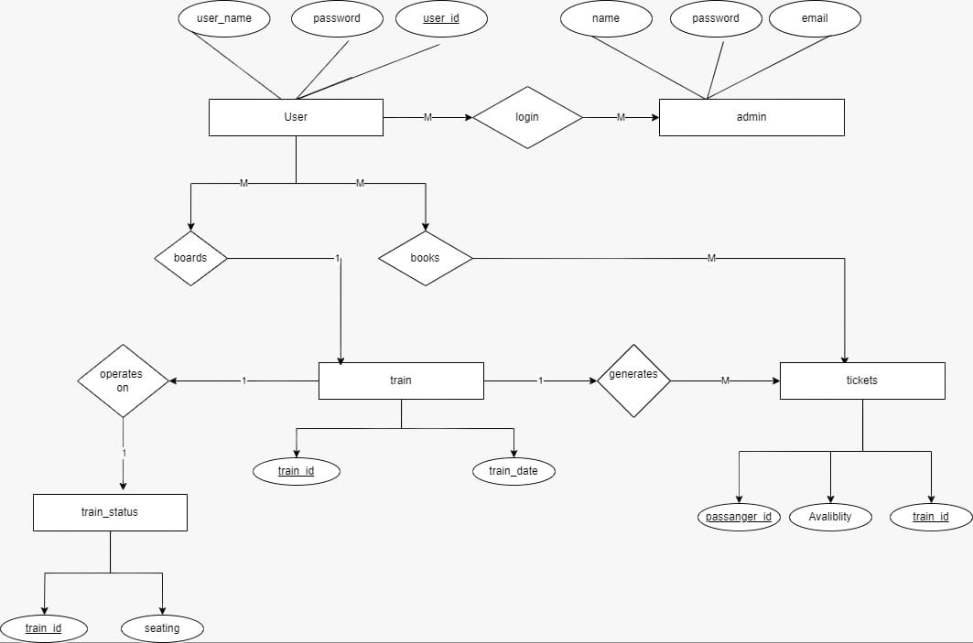

**3**

**Chapter-4 Tables / Collections**

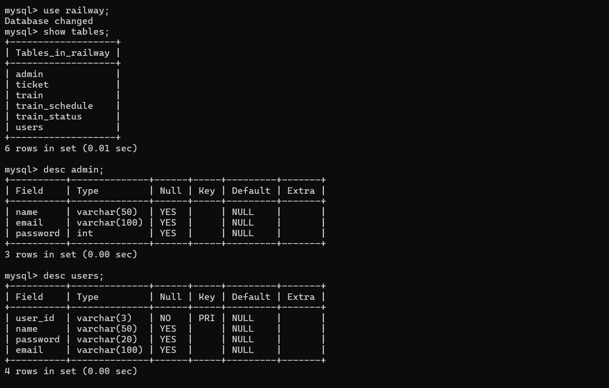

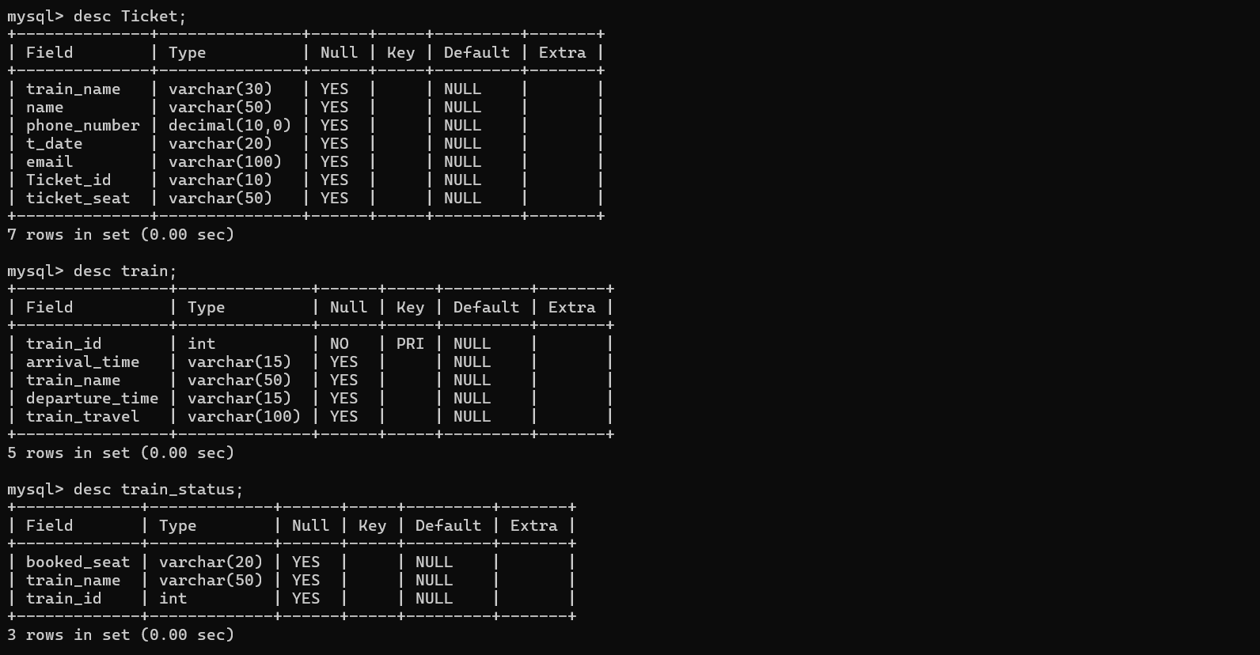

**4**

**Chapter-5 Forms**

**Login Page**

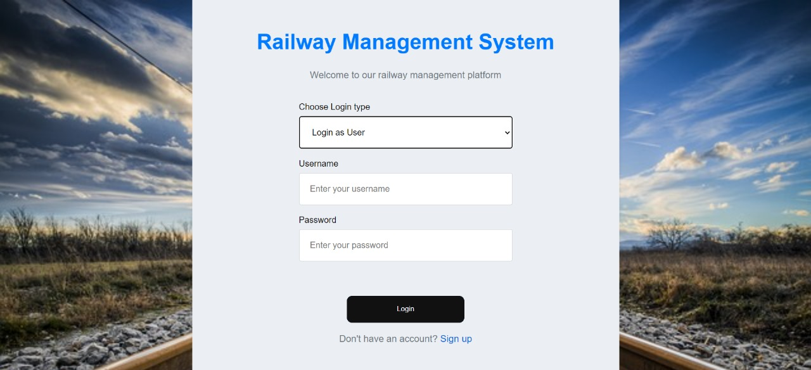

**Sign up**

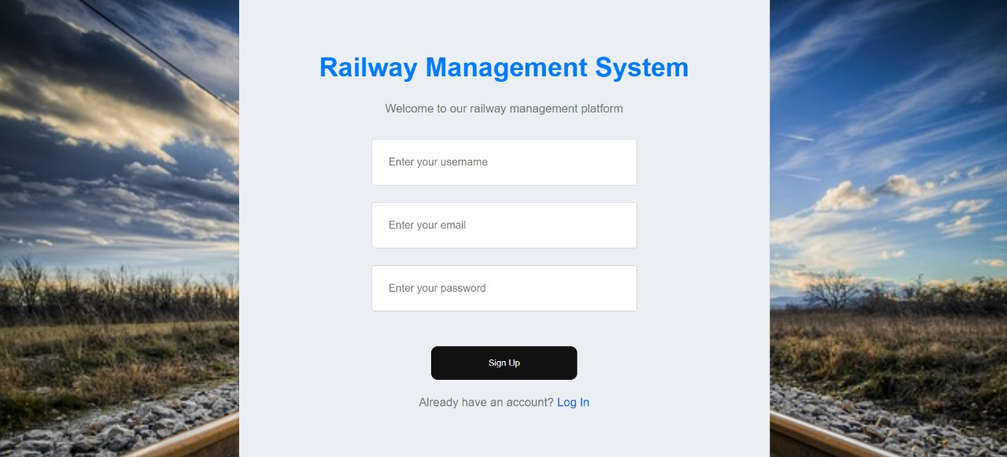

**5**

**About Us**

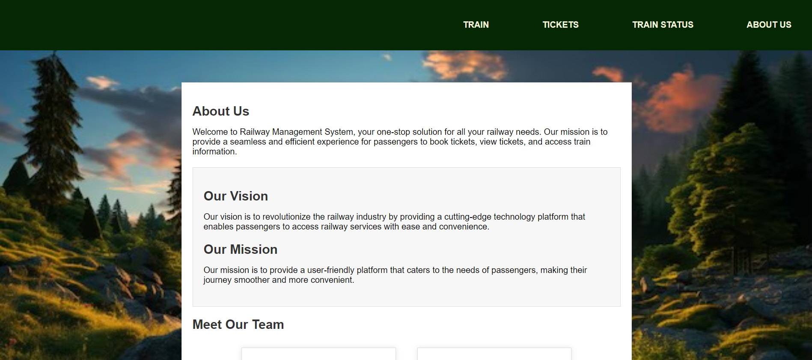

**Book Ticket**

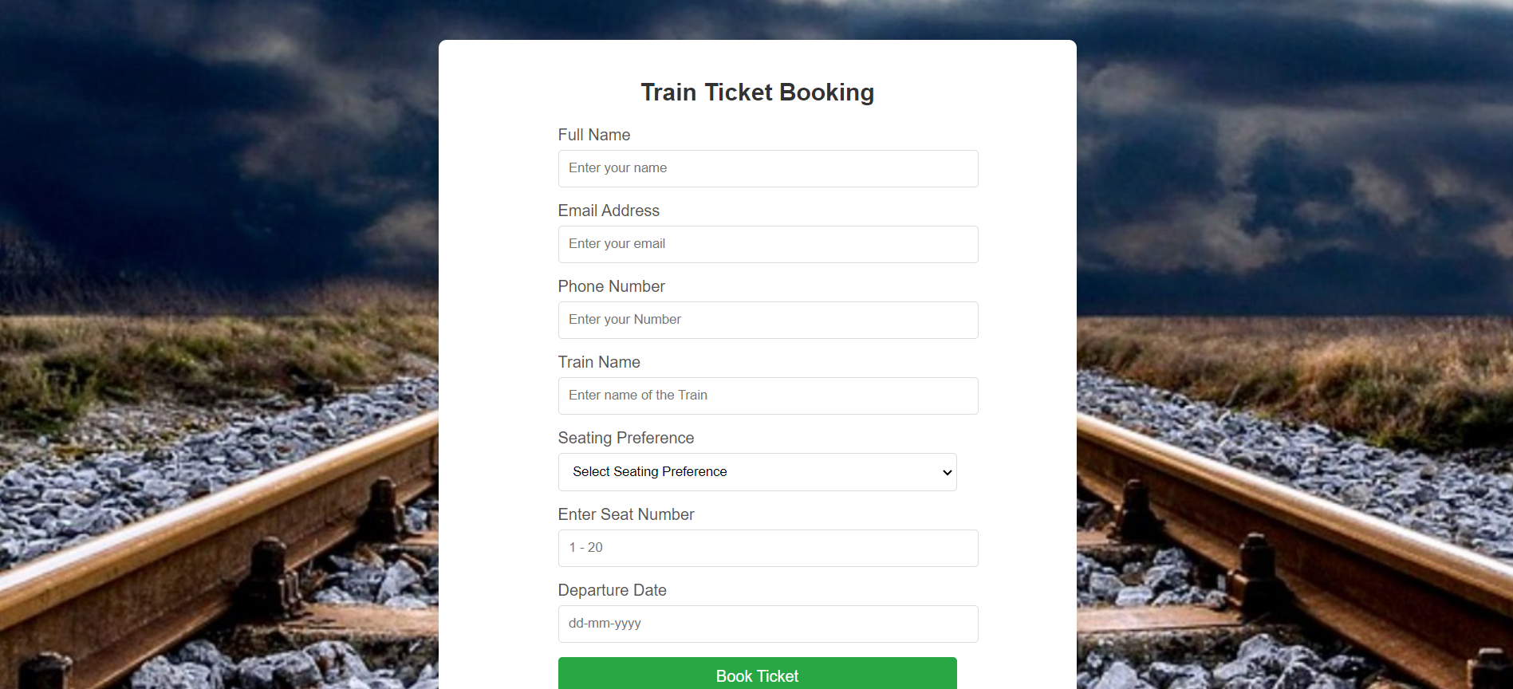

**6**

**View Ticket**

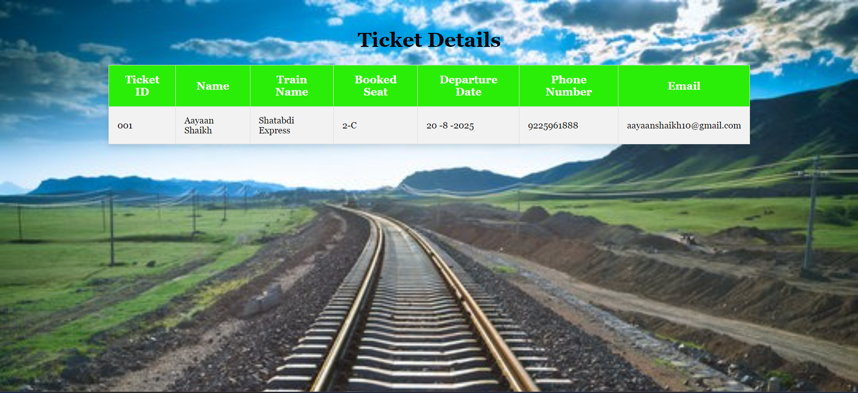

**Train**

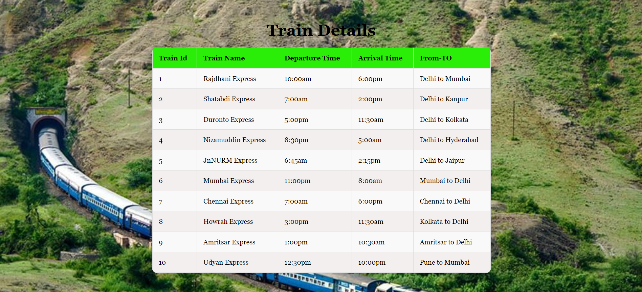

**7**

**Chapter- 6 Features**

* **User Management: The system allows users to register and log in with valid credentials while managing user accounts, profiles, and authentication.**
* **Train Schedule Management: It stores details of trains, including train number, name, route, and schedule, providing information on train availability based on source, destination, and date of travel.**
* **Booking Management: Users can book tickets by providing journey details such as date, passengers, and class, while also having the ability to cancel bookings and handle payment processing with unique PNR numbers generated for each booking.**
* **Seat Allocation: The system manages seat availability and assignment based on class and train configuration, assigning berths to passengers according to availability and booking order.**
* **Admin Functionalities: Authorized admins can manage train details, routes, schedules, and availability while handling refunds and cancellations as per defined rules through an admin dashboard for monitoring operations.**
* Passenger Information: It stores passenger details such as name, age, gender, and contact information while maintaining passenger history and preferences for personalized services.

**8**

**Chapter-7 Conclusion**

In our project, Railway Management System, we have stored all the information about the trains, schedules and the users booking tickets and even status of trains, seats, etc. This database is helpful for the applications which facilitate passengers to book train tickets and check the details of the trains and their status from their place itself. It avoids inconveniences of goin to railway station for each and every query they get. We had considered the most important requirements only, many more features and details can be added to our project in order to obtain even more user friendly applications.

**9**

**Chapter-8 References**

Oracle - <https://www.oracle.com/in/>

MySQL - <https://www.mysql.com/downloads/>

10